

SharePoint PREP Technical Documentation

Author: Chris Felknor
Last Modified: 12/30/06
By: Chris Felknor

Table of Contents

Table of Contents 2
Overview 4
PREP Overview 4
Design 4
Design Principles 4
Design Components 5
Classes and Students 5
SharePoint Representation 5
PREP Assignments 5
SharePoint Representation 6
PREP Tasks 6
SharePoint Representation 6
PREP Documents 7
SharePoint Representation 7
Folder Structure 7
Identification 7
Software Architecture 8
Assemblies 8
Web Parts 8
PREP Matrix 9
Building the PREP Matrix 9
PREP Administration 10
Event Handler 11
Insert 11
Update 12
Delete 15
HTTPHandlers 15
PREPUploadDownloadHandler 15
Upload 16
Download 16
Checkout 16
Business Objects 16
PREPAssignment 17
Public Instance Properties 17
Public Static Methods 17
PREPTask 17
Public Instance Properties 17
Public Static Methods 18
PREPDocument 19
Public Instance Properties 19
Public Static Methods 20
PREPRole 21
Public Instance Properties 22
PREPImpersonation 22
Public Instance Methods 22
Technical Walk-through 22
PREP Matrix 22
Event Handler 27
Upload an Ideas Document 27
Review Someone Else’s Ideas Document 27
Upload a Review 28
Development 29
Custom Web Parts 29
Visual Studio.NET Template 29
Visual Studio.NET Project 29
Installing the Web Part 29
Server 29
SharePoint Site 30
Document Event Handlers 30
.NET Project 30
Installation in SharePoint 30
Enable Custom Event Handlers in SharePoint 30
Install the Assembly into the GAC 31
Wiring the Event Handler to Your SharePoint Site 31
Debugging 32
Security Considerations 32
Impersonation 32
Strong Names 32
Custom Web Pages 33
ASP.NET Project 33
Security Issues 33
Debugging 34

Overview
This document describes the implementation of the PREP Process within Microsoft SharePoint Services. It is intended for is developers who want to understand or work on the code. It is assumed that you have a general understanding of SharePoint, including how custom development is done within the product, and that you are at least somewhat familiar with PREP. For more information on these topics, please see the section on SharePoint development starting on p. 33, and refer to the following documents:
- Installing SharePoint on a Windows 2003 Server: SharePoint PREP Installation (SharePoint PREP Installation.doc – MS Word document)
- For an introduction to SharePoint PREP from a user’s perspective: SharePoint PREP Version 2.0 (SharePoint PREP 2.0.ppt – MS PowerPoint presentation)

PREP Overview
PREP stands for Peer Review Evaluation Process. It is a workflow for design engineers, the goal of which is to help team of 4-6 designers produce the best possible design.
PREP requires a team and a design problem. Everyone on the team is given the task of independently coming up with a possible solution to the problem. Once this is complete, everyone on the team critiques everyone else’s designs. Then a team meeting is held, the outcome of which should be the team’s best design.
This process makes it possible for ideas to be evaluated independently of personalities. If the team meeting that is the final stage of PREP were held without the individual designs and critiques, designers who do not have dominant personalities might never have their ideas heard. Since there is no correlation between personality type and the quality of an idea, an open forum could prevent some good ideas from being heard and evaluated. In addition to being a good general design methodology, PREP helps to correct this problem.
The optimum team size is 4-6 persons. Too few persons produce too few ideas, and too many persons can make it difficult to reach consensus in the final meeting.

Design

Design Principles
We wanted to put PREP on the Web, in order to enable people who were distributed in space and time to be able to participate in the process.
A PREP web site would require a way to manage membership, documents, and tasks. Since these capabilities are already built into Microsoft SharePoint, we decided to use SharePoint as a foundation for our PREP implementation.
A key design principle was to leverage what already exists in SharePoint wherever possible. Therefore, every attempt was made to resist the temptation to create a separate database or a directory of custom .aspx pages. Every piece of data is persisted by SharePoint using its own API, the interfaces were done using SharePoint Web Parts, and the logic around what happens to the documents and tasks was done in a SharePoint Document Event Handler.

Design Components
This section describes the logical components of PREP, followed by a description of the way these components are represented within SharePoint.

Classes and Students
SharePoint is physically implemented as an ISAPI filter in IIS. It intercepts all HTTP requests to the web site and maps them to a SharePoint virtual site. All of the myriad sites and sub-sites in a SharePoint implementation do not exist in the file system of the server. Everything, including the files in a document library, is stored in a Microsoft SQL Server database. The SharePoint ISAPI filter interprets the URL path, then creates and returns the correct pages to the web browser.
Each SharePoint sub-site can have its own collection of users. These users must be implemented as Windows Domain Accounts. A key constraint of the SharePoint product is that it must exist within a Windows Domain.
Each SharePoint PREP site typically contains the students and teachers of one class, although a site could also just contain the members of one team.

SharePoint Representation
- A Class is represented as one SharePoint site. The users of the site (students and teachers) are members of the class.

PREP Assignments
A PREP Assignment is defined by its name, and three dates:
- Begin Date for the assignment, i.e. the date the assignment is given to the students
- Ideas Due Date – the date by which each student is required to create and upload an Ideas Document
- Reviews Due Date – the date by which each student is required to create and upload a document containing a review of the other team member’s ideas. There should be one review document for each other member of the team.

SharePoint Representation
A PREP Assignment is represented in SharePoint as three Events on the Events List (the built-in SharePoint calendar). In addition to being a convenient way to persist this data, this also allows these important dates to appear on the calendar. The three Events are:
- Assignment Given
- Ideas Due
- Reviews Due
These Events are identified as belonging to PREP via two custom fields:
  - Milestone (which contains values of Assignment Given, Ideas Due, or Reviews Due)
  - Assignment Name.

PREP Tasks
There are two kinds of tasks in PREP:
- Ideas Task. Each user has one. It is their obligation to create and upload an Ideas Document for the assignment.
- Review Task. Each user has one for every other member of the team (so if there are 6 team members, each user will have 5 Review Tasks). This is the obligation to review other team members’ ideas.

SharePoint Representation
SharePoint has a built in Task List which already contains information about the task, its priority, its status (Not Started, In Progress, or Completed), and who it is assigned to.
For PREP we use a custom task list called PREP Review Tasks. This is exactly like the built-in task list, with the addition of four custom fields:
- Document Name. This is the name of the Ideas Document the task pertains to.
- Document Author. This is the author of the Ideas Document the task pertains to.
- Assignment Name. The PREP Assignment name
- AssignedTo Login. The string Login Name of the user the task is assigned to. There is actually an AssignedTo field in a SharePoint task list, but this is set to an SPUser object. This object has a login name property, but it contains domain information and some other characters. We use just the string login name across the PREP application to determine the user.

PREP Documents
There are two kinds of PREP documents: an Ideas Document, and a Review document.
- Ideas Document: This contains a team member’s individual design solution.
- Review Document: This contains a critique of another team member’s Ideas Document.
There are no restrictions on what type of document may be a PREP document, or what it should be named.

SharePoint Representation
SharePoint comes with what are called Document Libraries. These are similar to file folders in Windows, except that they also include metadata (fields of information about the document), and are capable of versioning (storing prior versions, with check-out and check-in). SharePoint accomplishes these capabilities by actually storing all file data as BLOBs in SQL Server.
For PREP, we use a custom Document Library called PREP Documents. This library has two custom (meta-data) fields unique to PREP:
- PREP. This is a logical (Yes/No) field; the value will be set to Yes if this is a PREP Document (i.e., a document the Event Handler should care about).
- PREP Document Type. For PREP Documents, this can have one of two possible values: Ideas, or Review.

Folder Structure
PREP Documents are stored in a specific folder structure: /PREPDocuments/UserLoginName/PREPAssignmentName
“PREPDocuments” is a fixed string, UserLoginName and PREPAssignmentName are variables.

Identification
PREP uses a combination of the PREP bit (Y/N field), the document author, and the UserLoginName portion of the folder name to identify its documents, as follows:
Document Type | Author / Folder | PREP Bit
Ideas | AuthorLogin == FolderName | Yes
Review | AuthorLogin != FolderName | Yes
Non-PREP | Any Author, Folder | No

Software Architecture

Assemblies
SharePoint PREP is organized into two .NET assemblies, PREPMatrixWebPart and PREPWorkflow. There are no .aspx or .html files in the file system; the only site assets used by the PREP application other than the assemblies are a handful of image files used to support the PREP Matrix. These assemblies live in two Visual Studio projects, PREPWorkflow and PREPWebPartLibrary. The content of these assemblies is as follows:
- PREPWorkflow
  - Document Event Handler
  - Business Objects
  - HTTPHandlers
- PREPWebPartLibrary
  - Web Parts

Web Parts
SharePoint Web Parts are sub-units of a web page that may be dragged onto any SharePoint page. They typically completely encapsulate a particular piece of functionality, and are the basic building blocks of all SharePoint web pages. For PREP, we have two custom Web Parts: The PREP Matrix, which is the main user interface to PREP, and the PREP Administration Web Part.
The PREP Web Parts are kept in one assembly, which is produced by one Visual Studio Solution called PREPWebPartLibrary. Each Web Part lives in its own class file.

PREP Matrix
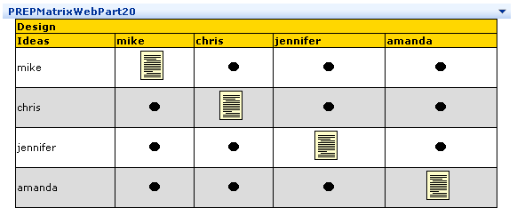
The PREP Matrix Web Part is the main user interface to PREP. It contains one row and one column for each member of the team. The intersection of a user’s row and column contains an icon representing that user’s Ideas Document. All other boxes contain Review Tasks.
For a complete discussion of how the PREP interface works from a user’s perspective, please see the PowerPoint presentation entitled SharePoint PREP Version 2.0.

Building the PREP Matrix
The PREP Matrix is constructed using a few concentric loops. The outermost loop is the collection of PREP Assignments for the site, an ArrayList of PREPAssignment objects (see PREPAssignment_Collection on p. 18). This collection will control the number of PREP Matrices, i.e. one for each assignment.
Inside of each assignment is a collection of users for that assignment, kept in SharePoint as a custom SPRole object called PREPRole (see description on p. 22). This loop controls the user rows and columns for each PREP Assignment.
Each user in an assignment’s PREP Role will cause a row to be written to the Matrix. For each user, the same role collection (represented by a different instance of the object) will be iterated through to create the columns.
The icons inside the boxes display state information, and contain hyperlinks to documents and tasks. If the user row and column are the same, the matrix will look for an ideas document. If it’s not there, it will look for an ideas task. Otherwise, it will look through the collection of PREP Tasks for the site to find the task that belongs in the current box in the matrix. There is logic (implemented as methods on the PREP business objects) to determine all of the state information and data (names and locations) needed to complete the icons on the matrix. See PREPDocument.GetIdeasDoc on p. 22; PREPDocument.GetReviewDoc on p. 22; PREPTask.GetIdeasTask on p. 20; and PREPTask.GetReviewTask on p. 20.

PREP Administration
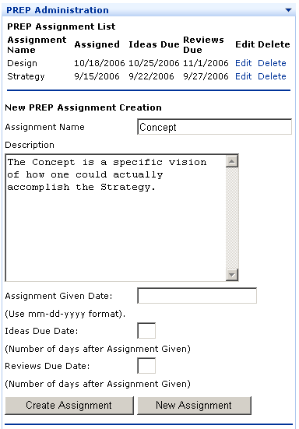
The PREP Administration Web Part is the Administrator’s interface.
It is actually possible to create everything you will need for a PREP assignment using web pages that already exist within SharePoint, since all of the data is standard SharePoint data. For example, since a PREP Assignment is defined by three events on the Events List, you could simply create these events using the Events List. However, this method is error-prone because failure to create everything the program is looking for will cause the PREP Matrix and Event Handler to malfunction. To avoid this problem, the PREP Administration Web Part was created. In addition to reducing errors, it greatly simplifies the task of administering PREP assignments.
The PREP Administration Web Part does three things:
- Create Events on the Event List in order to define PREP Assignments
- Create custom SharePoint roles to define users on PREP Assignments
- Add or Delete users from the custom SharePoint roles
  - When users are added or deleted from roles, their tasks are added or deleted as well. Any documents they may have created are left alone.

Event Handler
SharePoint has the ability to handle events on Document Libraries. The events it can respond to are insert, update, delete, copy, move, check-in, check-out, and un-check-out.
There are specific rules for writing Event Handlers within SharePoint. To simplify implementation, we have used Microsoft’s Event Handler Toolkit, available at
http://www.microsoft.com/downloads/details.aspx?FamilyID=4b2c2f1b-d74a-482a-903a-45bb44c5dec4&DisplayLang=en
We used an abstract class called BaseEventSink.cs, from the SampleEventSinks project. It encapsulates all of the basic functionality needed for a custom Event Handler. Our derived class for the PREP Event Handler is called PREPEventSink. It lives in an assembly and Visual Studio Project called PREPWorkflow.
The events handled by PREP are Insert, Delete, and Update. Following is a description of what happens when these events fire.

Insert
This is the event that fires when any document is uploaded to the PREP document library. Our handler only responds to valid PREP documents upon first-time upload.
The first thing the PREP Event handler does on an Insert is perform a number of checks to see if the document that was just uploaded needs to be processed. These checks are:
- Was the Insert triggered by a document or a folder? If a folder was created, no further processing is needed.
- Does the uploaded document have a valid PREP folder structure (PREPDocuments/UserName/AssignmentName)? If not, exit.
- Does the UserName exist? Does the Assignment name exist? Does the UserName belong to the Assignment? If not, exit.
- Does this user already have a PREP document in the current folder? If so, exit. There should only be one PREP document per folder per user.
If it is a valid PREP document that has been inserted, the first thing the event handler does is to change the custom PREP field (the PREP bit) to “Yes”. This is important, because PREP uses this to identify the documents that belong to it.
The next thing it has to do is determine whether the uploaded document is an Ideas Document or a Review document. This is accomplished by comparing the user login to the user name portion of the folder name (see above). Once this is done, it creates or updates the appropriate tasks on the PREP Task list.
Document Type | How Determined | Action Taken
Ideas | AuthorLogin == FolderName | Update user’s Ideas Task. Fill in the task’s Document Name field, and set the Status to “Completed”  Create a Review Task for each other user on the Assignment.
Review | AuthorLogin != FolderName | Set User’s Review Task Status to “Completed”.  If this is the last review, send an email to the Instructors Group (i.e. a custom SharePoint Role named “Instructors”) to inform them that the assignment is complete.

Update
One of the problems we experienced in earlier versions of SharePoint PREP was that students inadvertently overwrote other students’ documents. A common reason for this was that students would often create review documents from a copy of the ideas document. They would simply write on the original ideas document and upload it again. This worked fine if they remembered to rename their new document, but it caused problems if they did not.
A simple solution to this problem would be to evaluate the filename during an upload and not allow overwrites. However, we need to use SharePoint’s built-in upload mechanism because SharePoint is not a standard file system-based environment. Also, in keeping with our design principle, we want to use built-in SharePoint functionality whenever possible. So it’s not possible to alter SharePoint’s built-in file uploader to include some custom validation.
This leaves us with the Event Handler, which runs after something has already happened. So in order to prevent an accidental overwrite, we have to undo the upload.
Fortunately, SharePoint Document Libraries come with version control. This is turned off by default, but it is turned on in our PREP Document Libraries. This allows us to restore an earlier version of a document using the SharePoint object model. Doing this also automatically turns the just-uploaded version of the document into the new “prior” version, so it is not actually removed from the site.
Another problem that happens when SharePoint updates a document is that it overwrites the metadata (the SharePoint custom fields). It does this because it expects the user to fill in the values for the metadata fields on the upload form. This creates a problem for PREP, however, because our metadata is hidden from the user and only written by the system. Therefore, since the Event Handler runs after the file has already been uploaded, we have to put it back. This is more difficult than it would seem because PREP needs the metadata to identify its files! So, although we know what file was updated, and what folder it lives in, we have to indirectly figure out what its metadata should have been or whether it was a PREP file at all.
Since we have lost our metadata, we use the PREP Task list to figure out whether the updated file is one of our PREP files. This is easy to do in the case of an Ideas Document, because each user’s Ideas Task (their task to upload an Ideas document) contains the file name in the “Document Name” custom field.
It’s a little more difficult in the case of Review Task, since the “Document Name” field carries the name of the Ideas Document, not the Review Document. For all of the Review Tasks for the current assignment that pertain to the Ideas author referenced by the folder name, we can narrow the selection down to tasks that have a status of Completed. These are the ones that should have a corresponding Review Document. From these, we will look for missing documents. If we find that one is missing, we will assume that it is the one which was updated and that its metadata was removed.
Sometimes the document exists and its metadata is still intact. In these cases, we can compare the file name of the document to the uploaded file name. If they match, we can know with complete certainty which Review Document was just updated.
Here is a summary of what the Update Event Handler does:
- Determine whether we need to process the uploaded file
- Determine who the original author of the file was.
- Determine what kind of PREP document it is – Ideas or Review.
- Take appropriate action, as follows:

Document Type | Author | Actions Taken
Non-PREP | Anyone | None
Ideas | Uploader == Original Author | Restore Metadata
Ideas | Uploader != Original Author | Restore prior version  Restore Metadata  Email the Uploader (to inform them that they have to rename their file and upload it again)
Review | Uploader == Original Author | Restore Metadata
Review | Uploader != Original Author | Restore prior version  Restore Metadata  Email the Uploader (to inform them that they have to rename their file and upload it again)

Delete
If an Ideas Document is deleted from a PREP folder, all Review Tasks related to that document will also be deleted. The author’s Ideas Task will have its status reset to “Not Started”.
If a Review Document is deleted, no action is taken.

HTTPHandlers
There is one custom web page that has been written for PREP. In order to avoid having to put any .aspx pages on the server, this has been implemented as an HTTPHandler.

PREPUploadDownloadHandler
This class creates the page PrepUploadDownload.aspx. It is a “ghost” page – that is, it has no interface, and is simply passed through. It performs a few tasks, and then redirects the browser to its eventual destination. This is the page that is linked to by the icons on the PREP Matrix.
The behavior of this page is affected by four Querystring variables: filename, assignmentName, ideasAuthorName, and prepAction. Before any file processing is done, checking is done on assignmentName and ideasAuthorName. If the assignment does not exist, or the ideas author does not belong to the assignment, an exception is thrown. These values should never be incorrect if the page is linked to from the PREP Matrix, but these checks were put in place to discourage URL hacking. There is a switch statement controlled by prepAction. If that variable is incorrect, nothing will happen.
Following is a description of the different actions taken by this HTTP Handler.

Upload
When a user uploads an ideas document, this branch checks to see if the correct folder structure (PREPDocuments/UserName/AssignmentName) exists. If it does not exist, it is created.
Then, the browser is redirected to the standard SharePoint upload page. This page has a very complex querystring which tells SharePoint which folder the file should go into, and where the browser should be redirected to after the upload is complete. We had to code this carefully in order for our page to imitate the querystring SharePoint would have manufactured on its own.
The Event Handler takes care of all of the processing that should happen after an upload is complete. So if a user gets to this page by accident or decides not to upload a file, nothing happens to the PREP tasks or the state of the PREP Matrix. It will, however, create a folder – but not one that is not appropriate for this site or assignment.

Download
The download case is simple. The page simply figures out what the path to the document should be (based on the assignment name and user name), and redirects to that path.
Some file types (i.e. text or MS Office documents) will open right in the browser. Others will cause a download pop-up to appear.

Checkout
This is not a true checkout in the sense that a file is checked out in a Document Library. Rather, it simply sets a Review Task status to “In Progress” when a user clicks on one of their Review icons in the PREP Matrix, then redirects them to download the appropriate Ideas Document.

Business Objects
Much of the functionality in PREP is encapsulated in a set of four business objects: PREPAssignment, PREPTask, PREPDocument, and PREPRole. The discussion below covers the main methods and properties of these objects; for a complete object model reference, please see the Windows Help File SharePointPREP.chm (created using nDoc, available from http://ndoc.sourceforge.net/).

PREPAssignment
An instance of a PREPAssignment object represents one PREP Assignment. It is constructed by reading through the standard SharePoint Events list on the site, looking for events that have a value in the Assignment Name field.

Public Instance Properties
Assigned Date | Date this PREP Assignment begins.
Assignment Name | The PREP Assignment name
Description | PREP Assignment description.
IdeasDueDate | Date on which an Ideas document is due for this PREP Assignment.
ReviewsDueDate | Date on which the Review documents are due for this PREP Assignment.

Public Static Methods

PREPAssignment_Collection
Returns an ArrayList of PREPAssignment objects representing all of the valid PREP Assignments for this site. These objects are created by reading the Events list, looking for PREP Assignment events.

Create
Creates a PREP Assignment and returns the number of Events that were created.

Delete
Deletes a PREP Assignment and returns the number of Events that were deleted

PREPTask
This class represents a PREP Task. An instance is constructed by taking a task from the PREP Task List (the SharePoint list) and populating the public instance properties.

Public Instance Properties
AssignedTo | Login Name of the User the task is assigned to.
AssignmentName | The PREP Assignment Name.
DocumentAuthor | Ideas Document Author. This field names the Ideas Document Author, regardless of whether the task is an Ideas Task (an obligation to upload an Ideas Document) or a Review Task (an obligation to Review an Ideas Document). If this is an ideas task, the person named in the Document Author field will equal the person named in the AssignedTo field.
DocumentName | Ideas Document Name. This field names the Ideas Document, regardless of whether the task is an Ideas Task (an obligation to upload an Ideas Document) or a Review Task (an obligation to Review an Ideas Document).
DueDate | Date the Task is due.
Exists | Returns true if the constructor for the current instance was able to locate a persisted record corresponding to the requested key.
SPListItemObject | The complete SPList object taken from the SharePoint list. This has all of the properties, as well as the Update() method.
StartDate | Date the Task is assigned.
Status | Task Status: Not Started, In Progress, or Completed
Title | Task title. Contains information about the ideas document author, the assignment name, and the user it is assigned to.

Public Static Methods

Create
This method will create a PREP Task, assigned to one user, for the passed in assignmentName. The docAuthorLogin is the login of the author of the Ideas Document this task pertains to. The user is the user who the task is assigned to. If the docAuthorLogin == the user, this is the user's task to upload an ideas document. If the docAuthorLogin != the user, this is the user's task to review the docAuthor's ideas document.

DeleteTasksAssignedToUser
This will delete all tasks for one user for one assignment. This should be run if a user is removed from an assignment.

DeleteTasksRelatedToDocument
Deletes all PREP Tasks pertaining to a document, meaning the document's name is in the
PREPTask object's DocumentName field. The DocumentName field holds the name of the Ideas Document the task pertains to. The ideas task will be left in place, and its status will be reset to "Not Started".

DeleteTasksRelatedToUser
This will delete all tasks related to a user's Ideas Document for one assignment. It will
include the user's own task to create an Ideas Document, as well as other assignment members tasks to review that Ideas Document. This should be run if a user is removed from an assignment.

GetIdeasTask
Returns a user's (represented as userLoginName) "ideas" task - a task obligating them to create and upload an ideas document. If no such task exists, the Boolean "Exists" is set to false.

GetReviewTask
Returns a "review" task directing userLoginName to review ideasAuthorLoginName's ideas document. Boolean "Exists" is set to false if no such task exists.

PREPTask_Collection
An ArrayList of PREPTask objects. There are two versions of this: one contains all of the PREP Tasks for a site, and one contains all of the PREP tasks for one assignment.

PREPDocument
This is an object which represents a PREP Ideas or Review document. It may be constructed either from an SPFile object in the PREP Document library, or from an SPListEvent object inside the Event Handler.

Public Instance Properties
AssignmentName | The PREP Assignment name
DocType | The PREP Document Type. May be one of two values: Ideas or Review.
EventUserLogin | Login Name of the user whose action triggered the event on the document library. This field is only used in the Event Handler.
EventUserName | Display Name of the user whose action triggered the event on the document library.  This field is only used in the Event Handler.
Exists | True if a document exists for a given user and assignment.
FileName | The file name of the PREP document that triggered the event
Folder | The folder where the document resides (e.g. PREPDocuments/UserID/AssignmentName)
IdeasAuthorLogin | Login Name of the author of the ideas document that this document pertains to
PREP | PREP Bit. If True, this is a PREP Document. if PREP == true AND the document author userID == the folder name, it is an ideas document. if PREP == true AND the document author userID != the folder name, it is a review. if PREP == false, it is an extra document uploaded to the folder.
SPFileObject | The complete SPFile object

Public Static Methods

GetDocInfoFromURL
Takes a URL and returns a DocInfo struct. This struct breaks the URL out into IdeasAuthorLoginName, AssignmentName, and FileName. Additionally, there is a boolean IsValid which is set to false if the URL is not in the proper format. It does not check the validity of any of the data (i.e. it doesn't know if the user does not exist or the assignment name does not exist).

GetIdeasDoc
Returns the PREP Document object representing the Ideas Document for a given user (passed in as userLoginName) for a given assignment (assignmentName). If no such document can be found, Boolean field Exists is set to false.

GetReviewDoc
Returns the PREP Document object representing the Review Document for a given reviewer (reviewAuthorLoginName), reviewing the ideas of a given author (ideasAuthorLoginName), for a given assignment (assignmentName). If no such document can be found, Boolean field Exists is set to false.

IsNewPREPDocument
Returns true if the author of the passed-in document name does not already have a PREP document in the current folder. Used in the Event Handler to make sure that each user has only one PREP document in a given folder.

IsPREPFolder
Validates the following:
- The folder structure is in the correct format (PREP Documents/userName/assignmentName)
- The assignment exists
- The userName exists
- The userName belongs to the assignment

PREPDocument_Collection
Returns an ArrayList of all PREPDocument objects in a folder.

PREPRole
In Version 1.0 of SharePoint PREP, users on an assignment were always equal to the users of the site. In other words, every user on a site was included as a member of every PREP assignment. In practice, this turned out to be impractical; even if all of the students were on the assignment, the instructor was not.
In keeping with the design goal of storing all PREP data in standard SharePoint objects, this problem was solved by using custom SharePoint roles to contain the students on an assignment. SharePoint roles (the SPRole object) are essentially just collections of users (SPUser objects), with privilege attributes. They were designed to handle authorization groups in SharePoint.
This worked great but posed another problem. Since SharePoint uses these groups for authorization, it limits code access to the SPRole object to users who are in the Administrator Role. And even though SharePoint utilizes the Windows Identity Context to determine who its users are, it won’t allow access to the SPRole object via Windows Impersonation. It always considers the original user context, which it knows through properties in its own object model. In practical terms this meant that the PREP Matrix Web Part with student lists based on SPRole was only accessible to an Administrator.
SharePoint created this condition out concern for protecting the security of its roles, and thus offered no workaround. Therefore, we created our own custom Role object called PREPRole. This is nothing but a lightweight, read-only version of SPRole that anyone can use. It is constructed simply by using the same Stored Procedures used by SharePoint to read the tables which store the data which supports the SPRole object.
Since the student lists on PREP Assignments are controlled by Administrators, we simply use the standard SPRole object in the PREP Administration Web Part to create and update the roles. When we need to read out the users in the PREP Matrix, we use PREPRole.

Public Instance Properties
Description | Role Description.
Exists | True if the Role name requested in the constructor actually exists in the site (i.e, has been persisted in the database).
Name | Role Name.
Users | ArrayList of UserInfo structs, containing User LoginName, email, etc.

PREPImpersonation
This object allows code to impersonate a Windows user that is different from the logged-in user. Typically impersonation is used to execute code that requires a higher level of privilege than the user possesses (e.g. something that requires an Administrator).
We use it to allow the PREPRole object to execute SQL calls.

Public Instance Methods

Impersonate
Begins impersonating the user specified in the constructor, which takes arguments consisting of user id, domain, and password.

UnImpersonate
Stops impersonating the user specified in the constructor.

Technical Walk-through
The purpose of this section is to present the material described elsewhere in this document in a more narrative fashion, in order to offer an alternative and perhaps more interesting way of learning it. We’ll provide a behind-the-scenes look at what is happening during the normal operation of SharePoint PREP.

PREP Matrix
When a user opens a web browser to a SharePoint PREP site, the PREP Matrix Web part is activated. This Web Part is featured prominently on the page.
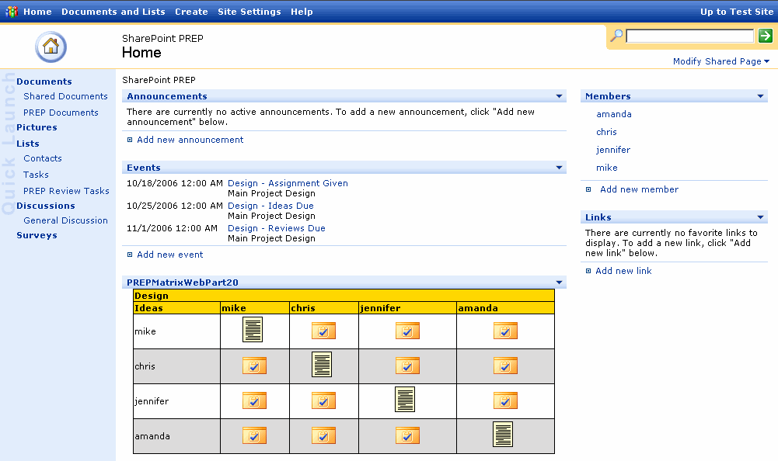
The PREP Matrix is created by looping through three objects:
- PREPTask.PREPTaskCollection (an ArrayList of PREPTask objects).
There is one PREP Matrix per assignment. Each iteration of this outermost portion of the loop creates one PREP Matrix.
  - PREPRole(assignmentName).
This object contains the users on an assignment. Each iteration of this loop creates one row of the PREP Matrix.
    - PREPRole(assignmentName).
This is actually a copy of the previous PREPRole object (it is a copy because it contains exactly the same information, but its index is at a different place). Each iteration of this loop creates the columns on the PREP Matrix. The column contains an icon, which indicates state information.
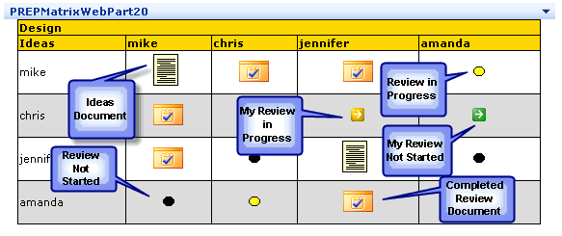
The logic behind the creation of the icons is determined by a number of factors:
- Who the logged-in user is
- Which user is on the current row of the matrix
- Which user is on the current column of the matrix
- Whether an ideas or review task exists for a user
- The status of the ideas or review task for a user (Not started, In Progress, etc.)
- Whether an ideas or review document exists for a user
The rows contain information about a user, i.e. what that user’s tasks are. The columns contain information about a document, i.e. different user’s tasks regarding that document.
Referring to the screen shot above, here is the underlying logic that drives the display. Icons described with call-out balloons are explained in detail in the following table. In this example, the logged-in user is chris.

Ideas | Mike | Chris | Jennifer | Amanda
Mike | Row user == column user, so look for Ideas task/document  Ideas Task Status = Completed, so look for a document  Result: Show document icon, link to Ideas document  Logged-in user? N  But all users see a link to the ideas document |  |  | Row user != column user, so look for a Review task  Review Task Status == In Progress  Logged-in User? N  Result: Show a non-clickable “Review In Progress” icon (yellow dot)
Chris |  |  | Row user != column user, so look for a Review task  Review Task Status == In Progress  Logged-in User? Y  Result: Show clickable “Review In progress” icon (yellow arrow). Clicking the icon allows the user to upload a Review | Row user != column user, so look for a Review task  Review Task Status == Not Started  Logged-in User? Y (meaning the row user, in this case chris)  Result: Show clickable “Review Not Started” icon (green arrow). Clicking the icon allows the user to download the Ideas Document that they are to review.
Jennifer
Amanda | Row user != column user, so look for a Review task  Review Task status == Not Started  Logged-in user? N  Result: Show non-clickable black “Review not started” icon |  | Row user != column user, so look for a Review task  Review Task Status == Completed  Logged-in User? N  Result: Show a clickable “Review Completed” icon (file folder w/check mark). All users may click on this icon to download the Review document.

Event Handler
This section tracks what happens when a user clicks on different icons in the PREP Matrix.

Upload an Ideas Document
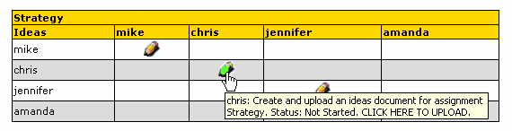
Here is the sequence of events behind an upload:
- User clicks the “pencil” icon to “write” or upload an ideas document
- User is sent to PREPUploadDownload.aspx, which
  - Creates folders if they do not exist in the form /PREPDocuments/UserLoginName/PREPAssignmentName
  - Redirects the user to the SharePoint upload page within the correct folders.
- User browses to and actually uploads a document (if the user cancels and does not actually upload anything nothing further happens)
- The Insert branch of the Event Handler fires, and
  - Determines that this is an Ideas Document
  - Creates review tasks for other users to review this document
  - Redirects the user to the folder which now contains the uploaded document.

Review Someone Else’s Ideas Document
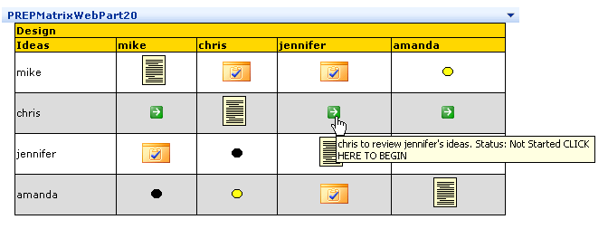
- User clicks the green arrow icon to download someone else’s ideas document.
- User is sent to PREPUploadDownload.aspx, which
  - determines what the folder structure of the ideas document to review, and
  - Sets the status of the User’s Review Task to “In Progress” using the SharePoint object model.
- Download of Ideas Document to be reviewed is initiated. User may save the document to their hard drive or open it from SharePoint (if it is a text document or another format that can be opened in the browser).
- Actual review of the document is performed off line, and should result in a new document which contains the review (shown in the next step).

Upload a Review
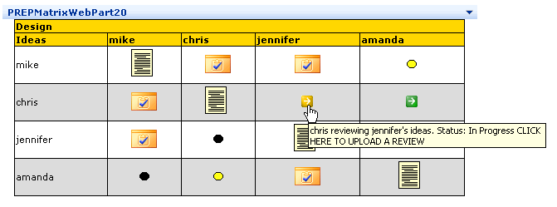
- User clicks the yellow icon to upload a review
- User is sent to PREPUploadDownload.aspx, which
  - Determines the correct folder for the review (the folder where the Ideas Document lives)
  - Redirects the user to the SharePoint upload page within the correct folder, using the correct query string (which insures post-upload redirection)
- User browses to and actually uploads a review document (if the user cancels and does not actually upload anything nothing further happens)
- The Insert branch of the Event Handler fires. It
  - Determines that this is a Review Document
  - Sets the User’s Review Task Status to “Completed”

Development
This section contains some general information about development within SharePoint.
It should be noted that SharePoint development must be done on a Windows 2003 Server that has SharePoint installed on it. You can actually compile the code on a machine that just has the SharePoint dlls copied to it (in order to satisfy the code references), but you can only run or test it on a SharePoint server.

Custom Web Parts
Here is how to create a custom Web Part that will work in SharePoint.

Visual Studio.NET Template
Before beginning to develop custom Web Parts, download the template for Visual Studio.NET, from this location:
http://www.microsoft.com/downloads/details.aspx?familyid=CAC3E0D2-BEC1-494C-A74E-75936B88E3B5&displaylang=en
This puts a new template in Visual Studio when you go to create a project.

Visual Studio.NET Project
Create a new project using the Web Part Library Template. Each class in this project will encapsulate one Web Part.
Before installation, the assembly will need a Strong Name. See the Security section on p. 37 for more information.

Installing the Web Part

Server
There is a very nice Web Part Installation Utility called InstallAssemblies here:
http://www.bluedoglimited.com/Downloads/pages/Web%20Part%20Toolkit.aspx
Instructions for InstallAssemblies:
- Double-click InstallAssemblies.exe
- Click the Select Assemblies button
- Browse to your web part dll and click Open
- Under Install location, make sure you choose the option to install it into the Global Assembly Cache (GAC).
- Click the Install button.
- After you see the "All done" message, close the InstallAssemblies window.

SharePoint Site
Once your custom web part has been installed on the server, you can add it to a SharePoint page with:
Modify Shared Page -> Add Web Parts -> Browse
When you have located your web part, drag it onto your page.

Document Event Handlers
This section contains some general information about development of document event handlers in SharePoint.

.NET Project
Create a class library project. When the project is created, add a .NET reference to Windows SharePoint Services.
The class you create has to have using Microsoft.SharePoint;, and it must implement the IListEventSink interface. This interface has one method, OnEvent, which will be invoked when an event occurs in a document library.
For a good example of how to do this, look at
Microsoft’s Event Handler Toolkit
http://www.microsoft.com/downloads/details.aspx?FamilyID=4b2c2f1b-d74a-482a-903a-45bb44c5dec4&DisplayLang=en
Look in the SampleEventSinks project, at BaseEventSink.cs. This has been implemented as an abstract class, which your custom classes can inherit from. It encapsulates all of the basic functionality you will need for your custom event handler.

Installation in SharePoint

Enable Custom Event Handlers in SharePoint
Your SharePoint site has to be configured to allow custom event handlers. By default, it will not allow them.
Go to SharePoint Central Administration:
Under Virtual Server Administration, click Configure virtual Server Settings.
Select the web site that your SharePoint virtual server is running on.
Under Virtual Server Management, click Virtual Server General Settings.
Scroll to the bottom of the page. Under the section marked Event Handlers, Click the radio button for Event Handlers are: on, and click OK.

Install the Assembly into the GAC
The assembly must be installed in the Global Assembly Cache in order to be used by SharePoint.
Before installation, the assembly will need a Strong Name. See the Security section on p. 37 for more information.
Here is a batch file that will install the assembly into the GAC:
@echo off
setlocal
set FrameworkDir="%windir%\microsoft.net\framework\v1.1.4322"
set gacutil="%FrameworkDir%\gacutil.exe"
echo Installing YourCustomEventHandler.dll into the GAC.
%gacutil% /if bin\YourCustomEventHandler.dll

Wiring the Event Handler to Your SharePoint Site
Once the Event Handler has been created, compiled, signed, and installed in the GAC, it must be known to a SharePoint document library before it can process events. Here is how:
- Browse to the doc library on the SharePoint site
- Modify Settings and columns.
- In the General Settings section, click Change advanced settings.
- In the boxes, type:
Assembly Name
YourCustomEventHandler, Version=1.0.0.0, Culture=neutral, PublicKeyToken=a96de2e4f2537f8d (You will have different values for these. The Assembly name, version, and PublicKeyToken may be found by looking in the GAC, at C:\Windows\assembly)
Class Name
YourCustomEventHandler.YourClassName (change this to your own values)

Debugging
Because custom event handler and web parts must run as assemblies installed into the GAC (see below), debugging must be done by attaching Visual Studio.NET to the w3wp.exe process.
- With your Visual Studio.NET project open, set the desired breakpoints.
- Click on Tools->Debug Processes
- Check the box for Show Processes in All Sessions.
- If you do not see w3wp.exe in the list of available processes, access your SharePoint site with a browser to in order to start it (usually necessary after an iisreset). Then hit the refresh button in the Processes box. It should now appear.
- Select w3wp.exe and click the Attach button.
- Select Common Language Runtime, Click OK, and click Close
- Do something that will activate your event handler or web part. The code should break on a breakpoint set in step 1.
Another thing you can do is have your event handler write to the Application Event Log, like so:
using System.Diagnostics;
EventLog.WriteEntry("YourAppName", "Text to write to the event log");

Security Considerations

Impersonation
One of the things your Event Handler code must do is impersonate a Windows account with authority on your SharePoint site. This bit of functionality is encapsulated in BaseEventSink.cs, mentioned above.

Strong Names
The assembly must be signed, because it eventually will need to be installed in the GAC. To do this, you will need to have installed the .NET Framework 1.1 SDK, because you will need the Strong Name Utility sn.exe. It may be found here:
C:\Program Files\Microsoft Visual Studio .NET 2003\SDK\v1.1\Bin\sn.exe
To use it, open the Visual Studio 2003 Command Prompt and navigate to the directory where your compiled dll is. Issue this command:
sn -k keyfile.snk
Copy keyfile.snk to your project directory. Open AssemblyInfo.cs, and find
[assembly: AssemblyKeyFile(“”)]
Change it to [assembly: AssemblyKeyFile(@"..\..\keyfile.snk")]
(NOTE: If you are going to compile from the command line, and not in Visual Studio, change it to [assembly: AssemblyKeyFile(@"keyfile.snk")]

Custom Web Pages
This section describes how to code custom .aspx pages that will work within SharePoint. We have not done this for PREP, but have included this material for reference.

ASP.NET Project
The easiest way to create a custom web page is to create an ASP.NET project as a subdirectory of the \_layouts directory in the SharePoint Site.
Once you have created this project, add a .NET reference to Windows SharePoint Services.
At a minimum, add a reference to Microsoft.Sharepoint on any page in which you are going to call the Object Model. You may want to add some other namespaces, as well:
using Microsoft.SharePoint;
using Microsoft.SharePoint.WebControls;
using Microsoft.SharePoint.Administration;
using Microsoft.SharePoint.Utilities;

Security Issues
If these pages are going to simply list things from SharePoint, there will be no security problem. If they are going to update the Sharepoint database, however, you will need to add this to the .aspx page:
<%@ Register Tagprefix="SharePoint" Namespace="Microsoft.SharePoint.WebControls" Assembly="Microsoft.SharePoint, Version=11.0.0.0, Culture=neutral, PublicKeyToken=71e9bce111e9429c" %>

Just under the <form> tag, add this:
<SHAREPOINT:FORMDIGEST id="Formdigest1" runat="server"></SHAREPOINT:FORMDIGEST>

Debugging
You may notice that your site will not run in the IDE. This is because the IDE may not have the correct path to the SharePoint site you are trying to debug. Since all SharePoint sites share the same code base, and their URL is a virtual construction whose origin is in the database, you just need to correct the URL once the debugger has started. For example:
URL to your page from Visual Studio:
http://localhost/_layouts/ProjectName/WebForm1.aspx

SharePoint URL to your page in the “SubSPSite” project:
http://localhost/TopSPSite/SubSPSite/_layouts/ProjectName/WebForm1.aspx

In this example, Visual Studio would start debugging with the first URL. You would manually correct the URL in the address box to the second one.
An easy way to deal with this is to create a default.aspx page which contains a link to the real site you are working on (e.g., the second URL above).

